Algebra 3-4 Name: ____________________

Chapter 2 Retest Block: ________

2.1 Represent relations and functions Objective Met: Yes/No
2.1 Graph and evaluate linear functions Objective Met: Yes/No
2.2 Find slope and rate of change Objective Met: Yes/No
2.2 Classify parallel and perpendicular lines Objective Met: Yes/No
2.3 Use slope intercept form to graph linear equations Objective Met: Yes/No
2.3 Use standard form to graph linear equations Objective Met: Yes/No
2.3 Graph horizontal and vertical lines Objective Met: Yes/No
2.4 Write linear equations, emphasizing point-slope form Objective Met: Yes/No
2.6 Graph linear inequalities in two variables Objective Met: Yes/No

For problem 1 – 2, find the slope of the line passing through the given points.

1. (5, 1), (-4, 3) 2. (7, -6), (7, -9)

For problems 3 – 4, tell whether the lines are parallel, perpendicular, or neither.

3. Line 1: through (4, 2) and (2, 1) 4. Line 1: through (0, -7) and (2, -3)
Line 2: through (5, -5) and (3, -6) Line 2: through (-8, 6) and (0, 3)

For problem 5, select the slope-intercept form of the line with the given information.

5. 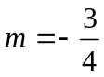, 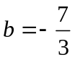

A. 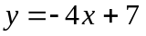

B. 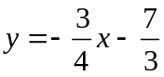

C. 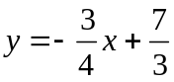

D. 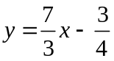

For problem 6 – 8, write the equation of the line in point-slope form AND slope-intercept form.
6. Through the point (12, 6) with slope 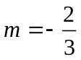.
Point-slope: _____________

Slope-intercept: _________

7. Through the points (8, 12) and (2, -8).

Point-slope: _____________

Slope-intercept: _________

8. The line passes through (2, 6) and is perpendicular to y = 2x – 3.

Point-slope: _____________

Slope-intercept: _________

For problem 9, graph the function. Identify the domain and range. Then tell whether the relation is a function.

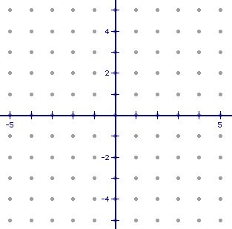
9. a. b. Domain: _________
Input | Output
0 | -4
0 | 4
2 | -2
2 | 3
4 | -1
4 | 1
c. Range: ___________

d. Is the relation a function ?
Yes or No

For problems 10 – 11, state the slope and y-intercept. Then graph the function.
10. y = 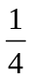x 11. y = -3x + 5

slope = ______ y-intercept = _____ slope = _____ y-intercept = _____

For problem 12, state the slope. Then graph the function.
12. x = -4

slope = _____

For problem 13, find the x and y intercepts. Then graph the equation.

13. 6x + 3y = 12

x-intercept: _____ y-intercept: _____

For problem 14, state whether the function is linear. Then evaluate the equation for the given value of x.

14. If 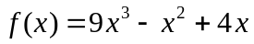

- Is the function linear?

b. Evaluate 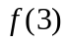.

For problem 15, select the correct answer.

15. Which is a solution to the inequality 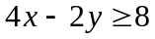?

A. (-5, 5)

B. (-2, -9)

C. (3, 3)

D. (4, 10)

For problems 16 – 18, graph the inequalities.

16. y > 3 17. 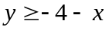

18. -2x + y < -3

For problems 19 – 21, use the given information to answer the problems.

19. In order for this year’s star basketball player to break the school record for most points (excluding free throws), he must score at least 42 points. The points may be scored by two-point shots and three-point shots. Write an inequality that represents the number of two and three-point shots he needs to break the record. Then Graph the inequality.

20. The school theatre group is selling bags of cookies and cupcakes to raise money for the upcoming musical. The cookies are $2.50 per bag and the cupcakes are $1.25 per bag. Each student has a goal to sell exactly $30 worth of cookie and cupcake bags. Write a model that shows the number of cookie and cupcake bags that each student must sell. Then graph the model.

21. Tim is trying to lose weight for wrestling. He begins the season at 150 pounds. At the end of the fourth week of practice, he weighs 140 pounds. Find the average rate of change, in pounds per week, of Tim’s weight.

